Regex and DFA

1. Number: [0-9]+(“.”[0-9]+)?

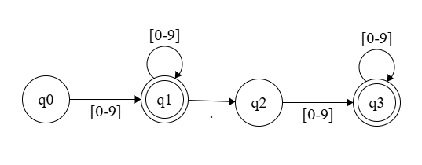

1. String: (“)([a-z] | [A-Z] | [0-9] | + | - | * | & | $)*(”)

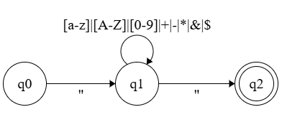

1. Reserved_Keywords:  
   int|float|string|read|write|repeat|until|if|elseif| else|then|return|endl

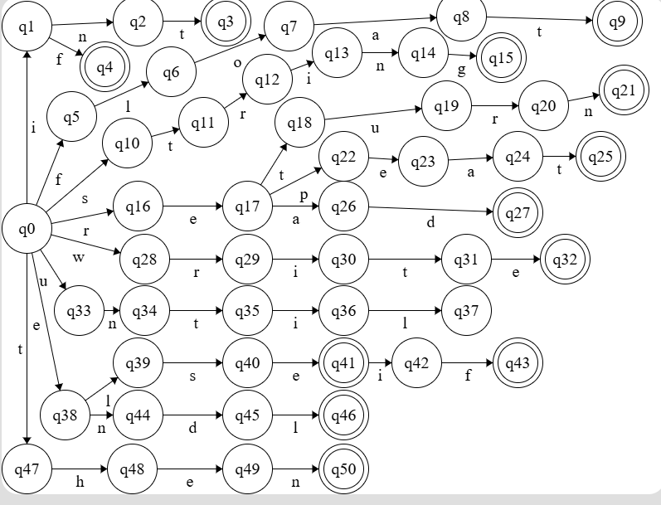

1. Comment_Statment: (/)(*)([a-z] | [A-Z] | [0-9] |+|-|*|&|$|)*(*)(/)

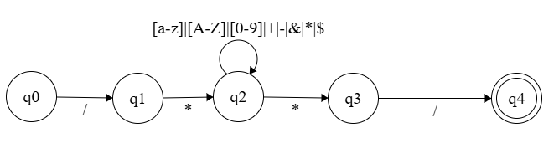

1. Identifier: ([a-z]|[A-Z])+([a-z]|[A-Z]|[0-9])

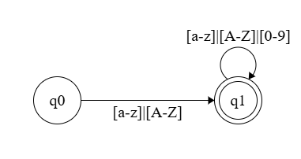

1. Function_Call: Identifier \(((Identifier)(,Identifier)*)*\)

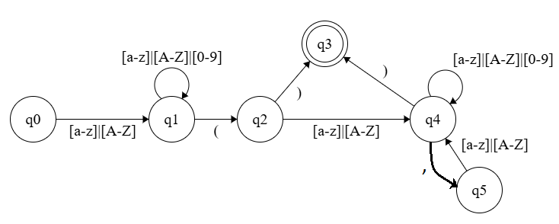

7) Arithmatic_Operator: (+|-|*|/)

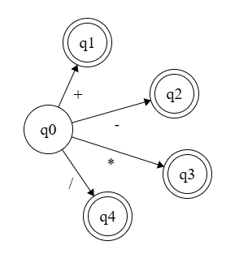

8) Condition_Operator (>|<|=|<>)

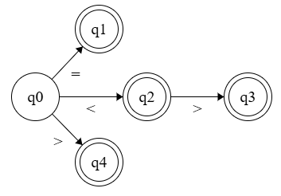

9) Boolean_Operator (“&&”|”||”)

